- Call to Order — Serenity Prayer

- Roll Call Service Members

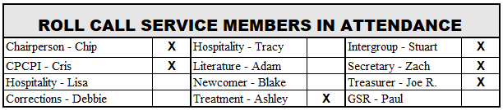

- Reports & Updates -

  - Meeting Minutes - *Motion to Approve/2nd

    - Treasury Report – Joe R

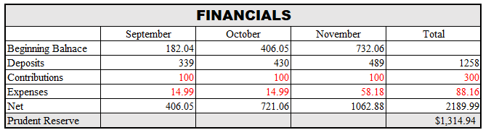
*Motion to Approve/2nd

  - Greeters – everything is going well

  - GSR Report (provided with meeting agenda)

    - District 21 has 15 Open positions – service opportunity to get at District Level

  - Intergroup Report (provided with meeting agenda, notes below)

- Dallas Intergroup office is open and available to serve groups
- Limited activities currently
- Manager will be leaving at the end of the year and search for replacement underway.
- Kim, the Treatment Center coordinator has been actively working with several treatment centers to offer online meetings. Dallas County jail is also now holding online meetings
- Many groups have begun in person meetings while taking action including reduced capacity, masks, hand sanitizer and social distancing
- Intergroup is updating 12 Step List for every group. Contact Stuart if you are interested in getting involved and being added to the list for the Unfortunates
- Nightwatch takes phone calls for Intergroup during off hours. Another great service opportunity that demands little time (min. -1 shift per quarter) Contact Stuart if interested

  - Treatment –
    - Life Path meetings. Sign up available online. Chip shared that this is a great experience to share your story approximately 40 minutes and take questions
    - Ashley is interested in stepping down as treatment chair. She has done a phenomenal job with this commitment and if you are interested in a service commitment please contact Chip.
  - Literature –
    - Announcement at end of meeting directing attendees to AA.org
    - GSO is experiencing delays up to 8 weeks fulfilling literature requests, so emphasize the download options at AA.org
  - Secretary –
    - Send email request to secretary@unfortunates.org to get added to the distribution list for TUG communications
    - Suggest mentioning at the end of the meeting for newcomers who may be interested

- Old Business
    - Chris C provided update some other groups on the east and west coast are doing hybrid meetings incorporating go-pro, sound bar, laptop
    - Some CA groups are meeting after clearing with state and local officials regarding rules prior.
- New Business

    - Ashley stepping down as Treatment Chair – Position is open
    - Insurance is coming due for the year in February in the amount of $495. need to discuss renewal. $495. Joe R and Chris to check with our insurance agent and see options if we can easily obtain new coverage once in-person meetings resume. TUG needs clarification on if any challenges to reinstating coverage at a future point in time is reasonable to avoid unnecessary costs with current meeting format. Joe and Chris to advise the steering committee if any issues prior to making payment or allowing policy to temporarily lapse.

- 7th Tradition Venmo Announcement

- Close – Lord’s Payer

